Transformer Winding Specification 1

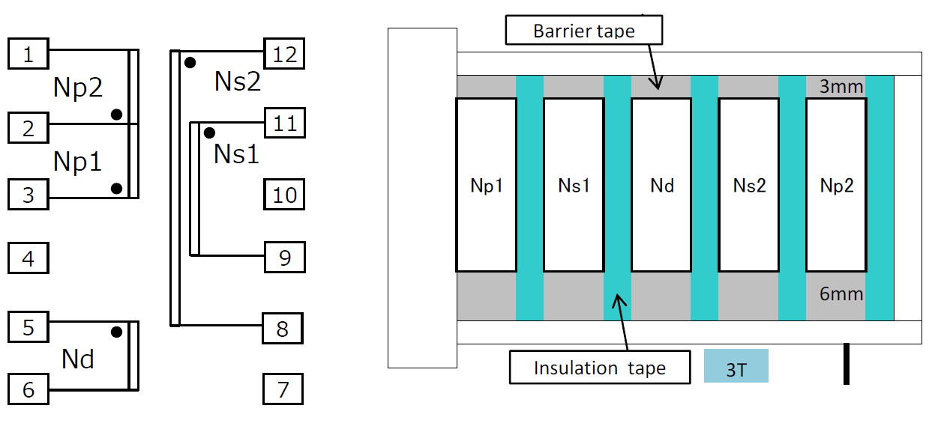

Core: PQ26/20
Bobbin: Vertical/Terminal Pins 6-6(12pins) or compatible
AL – Value: 182.61 nH/N²
Inductance (1 – 3 pin): 260 µH (0.26 mH ±10%)
Primary to secondary isolation: ≥ 4kV

Coil | Pin number | Number of turns | Wire gauge
Np1 | ‘3-2 | 18 | SWG #21
Ns1 | ‘11-9 | 28 | SWG #20
Nd | ‘5-6 | 10 | SWG #23
Ns2 | ‘12-8 | 28 | SWG #20
Np2 | ‘1-2 | 19 | SWG #21

Winding direction: Uniformed

